MART HOME AUTOMATION

SOIL MOISTURE MONITORING SYSTEM

**A PROJECT REPORT**

**A PROJECT REPORT**

***Submitted by***

**BHUVANESH C S (210701042)**

**EASWARAN T (210701058)**

**GOKULA KRISHNA H (210701062)**

***in partial fulfilment for the award of the degree of***

# BACHELOR OF ENGINEERING IN

**COMPUTER SCIENCE RAJALAKSHMI ENGINEERING COLLEGE**

# THANDALAM





**MAY 2024**

**BONAFIDE CERTIFICATE**

This is to certify that this project report titled **“SOIL MOISTURE MONITORING SYSTEM**” is the bonafide work of **“BHUVANESH C S (210701042) EASWARAN T (210701058) GOKULA KRISHNA H (210701062)”** who carried out the project for the course CS19P11 Internet of Essentials work under my supervision.

## SIGNATURE

## MR.S.SURESH KUMAR,M.E.,

## .S.SURESH KUMAR,M.E.,

Professor

Department of Computer Science and Engineering Rajalakshmi Engineering College

Chennai - 602 105

This project report is submitted via viva voce examination to be held on_____________ for the course CS19P11 Internet of Essentials at Rajalakshmi Engineering College, Thandalam.



# ACKNOWLEDGEMENT

First and foremost, I acknowledge the amazing Grace of God Almighty, who blessed my efforts and enabled me to complete this thesis in good health, mind, and spirit.

I am grateful to my Chairman **Mr.S.Meganathan**, Chairperson **Dr.Thangam Meganathan**, Vice Chairman **Mr.M.Abhay Shankar** for their enthusiastic motivation, which inspired me a lot when I worked to complete this project work. I also express our gratitude to our principal **Dr.S.N.Murugesan** who helped us in providing the required facilities in completing the project.

I would like to thank our Head of Department **Dr. P. KUMAR** for his guidance and encouragement for completion of project.

I would like to thank **MR.S.SURESH KUMAR,** our supervisor for constantly guiding us and motivating us throughout the course of the project. We express our gratitude to our parents and friends for extending their full support to us.

# ABSTRACT

In response to the persistent challenges of inefficient water management in agriculture, this paper proposes the development of an integrated soil moisture monitoring system aimed at revolutionizing irrigation practices. Current systems suffer from limitations in real-time data collection, analysis, and decision support, hindering farmers' ability to optimize water usage and enhance crop yields. The proposed system addresses these shortcomings by incorporating advanced sensor technology, seamless data acquisition, and user-friendly interfaces. Leveraging high-precision sensors and real-time data transmission, the system provides farmers with actionable insights into soil moisture levels, irrigation needs, and crop health, enabling them to make informed decisions promptly. Cloud-based analytics further enhance the system's capabilities, offering in-depth data analysis and visualization tools accessible through web and mobile platforms. Additionally, the system's scalable architecture facilitates easy deployment and integration into existing agricultural infrastructure, ensuring widespread adoption and accessibility. By empowering farmers with timely information and decision support tools, the proposed soil moisture monitoring system aims to optimize water usage, increase crop productivity, and promote sustainable farming practices. Through its comprehensive approach and innovative features, the system has the potential to drive significant improvements in resource efficiency and environmental sustainability within the agricultural sector, ultimately contributing to global food security and resilience in the face of climate change. In addition to its core functionalities, the proposed soil moisture monitoring system prioritizes affordability and scalability, making it accessible to farmers across diverse agricultural settings. By minimizing upfront costs and offering flexible deployment options, the system aims to overcome financial barriers and ensure widespread adoption. Moreover, ongoing research and development efforts focus on enhancing the system's resilience to environmental factors and expanding its compatibility with emerging agricultural technologies. Through continuous innovation and collaboration, the system seeks to remain at the forefront of sustainable irrigation practices, driving positive change in agricultural communities worldwide.

# TABLE OF CONTENTS

|  |  |  |
| --- | --- | --- |
| **CHAPTER NO** | **TITLE** | **PAGE NO.** |
|  | **ACKNOWLEDGEMENT** | **iii** |
|  | **ABSTRACT** | **iv** |
|  | **LIST OF FIGURES** | **vii** |
|  | **LIST OF TABLES** | **viii** |
|  | **LIST OF SYMBOLS** | **ix** |
|  | **LIST OF ABBREVIATIONS** | **x** |
| **1** | **INTRODUCTION** | **1** |
| 1.1 | INTRODUCTION | 1 |
| 1.2 | PROBLEM STATEMENT | 3 |
| 1.3 | SOLUTION | 3 |
| 1.4 | SUMMARY | 5 |
| **2** | **LITERATURE SURVEY** | **7** |
| 2.1 | EXISTING SYSTEM | 9 |
| 2.2 | PROPOSED SYSTEM | 10 |
| **3** | **SYSTEM SPECIFICATION** | **11** |
| 3.1 | SYSTEM ARCHITECTURE | 11 |
| 3.2 | REQUIREMENT SPECIFICATION | 12 |
| 3.3 | COMPONENTS USED | 12 |
| 3.4 | WORKING PRINCIPLE | 14 |

|  |  |  |
| --- | --- | --- |
| **4** | **RESULT AND DISCUSSION** | **15** |
| 4.1 | ALGORITHM | 15 |
| 4.2 | IMPLEMENTATION | 16 |
| **5** | **OUTPUT** | **18** |
| 5.1 | OUTPUTS | 18 |
| 5.2 | SECURITY MODEL | 21 |
| **6** | **CONCLUSION AND FUTURE WORK** | **22** |
| 6.1 | CONCLUSION | 22 |
| 6.2 | FUTURE WORK | 23 |
|  | **REFERENCES** | **25** |
|  | **APPENDIX** | **26­­­** |

**LIST OF FIGURES**

|  |  |  |
| --- | --- | --- |
| **FIGURE NO.** | **NAME OF FIGURES** | **PAGE NO.** |
| 3.1 | System Architecture | 11 |
| 5.1 | Output Screen | 17 |
| 5.2 | : Capacitive soil Moisture sensor version 2 | 18 |
| 5.3 | Project Setup | 18 |
| 5.4 | Too wet- indicates red color | 19 |
| 5.5 | Perfect moisture soil for plants indicates green color | 19 |
| 5.6 | Too dry - Time to water soil ( indicates blue colour) | 20 |

# LIST OF TABLE

|  |  |  |
| --- | --- | --- |
| **TABLE NO.** | **NAME OF TABLE** | **PAGE NO.** |
| 4.1 | Components Table | 14 |

**LIST OF SYMBOLS**

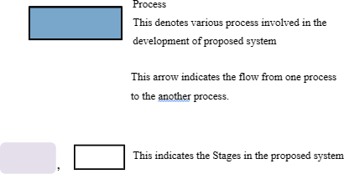

# ABBREVIATIONS

1. IoT - Internet of Things
2. SDK - Software Development Kit
3. IDE - Integrated Development Environment
4. Wi-Fi - Wireless Fidelity
5. LED - Light Emitting Diode
6. CAD - Computer-Aided Design
7. API - Application Programming Interface
8. USB - Universal Serial Bus
9. GPIO - General Purpose Input/Output
10. MCU - Microcontroller Unit

# CHAPTER 1 INTRODUCTION

* 1. **INTRODUCTION**

In the realm of agriculture, the efficient management of water resources stands as a cornerstone for sustainable and productive farming practices. Soil moisture, a critical parameter influencing crop growth and health, serves as a vital indicator of water availability in agricultural fields. Traditional methods of monitoring soil moisture often entail manual labor and subjective assessments, leading to inefficiencies and inaccuracies in irrigation management. However, with the advent of Internet of Things (IoT) technology, a paradigm shift has occurred in the domain of soil moisture monitoring, offering unprecedented capabilities for real-time data collection, analysis, and decision support.

The integration of IoT devices into soil moisture monitoring systems represents a significant advancement in agricultural technology, enabling farmers to access accurate and timely information about soil moisture levels across their fields. These IoT devices, equipped with sensors capable of measuring soil moisture content at various depths and locations, provide invaluable insights into the water status of crops and soil conditions. By continuously monitoring soil moisture levels, farmers can make data-driven decisions regarding irrigation scheduling, optimizing water usage, and maximizing crop yields.

One of the key advantages of IoT-based soil moisture monitoring devices lies in their ability to offer real-time data transmission and remote accessibility. Through wireless connectivity and cloud-based platforms, farmers can remotely monitor soil moisture levels from anywhere, at any time, using computers, smartphones, or other internet-enabled devices. This remote accessibility not only enhances the convenience of monitoring but also facilitates proactive decision-making, allowing farmers to respond promptly to changes in soil moisture conditions and environmental factors.

Moreover, IoT devices for soil moisture monitoring often feature advanced analytics capabilities, enabling farmers to gain deeper insights into soil-water dynamics and crop-water relationships. By leveraging data analytics algorithms, these devices can generate predictive models, identify trends, and provide recommendations for optimizing irrigation strategies. Additionally, some IoT-based soil moisture monitoring systems offer integration with weather forecast data, enabling farmers to anticipate future soil moisture conditions and adjust irrigation schedules accordingly.

Despite the numerous benefits offered by IoT-based soil moisture monitoring devices, challenges remain in terms of cost, scalability, and user adoption. The initial investment required for purchasing and installing IoT devices may pose financial barriers for small-scale farmers, necessitating efforts to develop cost-effective solutions and incentivize adoption. Furthermore, ensuring the scalability and interoperability of IoT devices across different agricultural contexts and regions remains a critical consideration for maximizing their impact and reach.

In conclusion, IoT-based soil moisture monitoring devices hold immense promise for revolutionizing irrigation management in agriculture, offering farmers unprecedented access to real-time data, advanced analytics, and remote monitoring capabilities. The initial investment required for purchasing and installing IoT devices may pose financial barriers for small-scale farmers, necessitating efforts to develop cost-effective solutions and incentivize adoption.By harnessing the power of IoT technology, farmers can optimize water usage, enhance crop productivity, and promote sustainable farming practices, ultimately contributing to global food security and environmental sustainability.

## PROBLEM STATEMENT:

## Inefficient water management in agricultural practices often leads to suboptimal crop yields, water wastage, and environmental degradation. Existing soil moisture monitoring systems lack comprehensive real-time data acquisition, analysis, and decision support capabilities, hindering farmers' ability to make timely and informed irrigation decisions. Additionally, current systems may lack scalability, affordability, and user-friendly interfaces, limiting their adoption and effectiveness in diverse agricultural settings. There is a pressing need for the development of an integrated soil moisture monitoring system that offers robust sensor technology, efficient data acquisition and analysis, user-friendly interfaces, and scalable solutions to optimize water usage, improve crop productivity, and promote sustainable agricultural practices.

## 1.3 SOLUTION:

In the quest for more accurate, reliable, and efficient soil moisture monitoring, capacitive soil monitoring sensors have emerged as a groundbreaking solution, poised to revolutionize agricultural practices worldwide. Unlike traditional methods that rely on manual measurements or cumbersome equipment, capacitive soil monitoring sensors offer real-time, non-invasive, and high-precision monitoring of soil moisture levels, providing farmers with invaluable insights into soil-water dynamics and crop health.

At the heart of capacitive soil monitoring sensors lies the principle of capacitance, whereby changes in soil moisture alter the dielectric properties of the soil, leading to variations in capacitance. These sensors typically consist of two electrodes embedded within the soil, with one serving as a transmitter and the other as a receiver. As moisture levels in the soil fluctuate, the capacitance between the electrodes changes, allowing the sensor to accurately measure and quantify soil moisture content.

One of the key advantages of capacitive soil monitoring sensors is their ability to offer continuous, real-time monitoring of soil moisture levels across various depths and locations within the agricultural field. By providing farmers with precise data on soil moisture dynamics, these sensors enable informed decision-making regarding irrigation scheduling, water management, and crop health monitoring. Moreover, capacitive soil monitoring sensors are highly sensitive to changes in soil moisture, allowing for early detection of water stress in crops and timely intervention to mitigate potential yield losses.

Furthermore, capacitive soil monitoring sensors are known for their durability, reliability, and low power consumption, making them well-suited for long-term deployment in agricultural environments. With advancements in sensor technology and wireless connectivity, these sensors can now transmit data wirelessly to centralized platforms or mobile devices, enabling farmers to remotely monitor soil moisture levels and receive alerts or notifications in real-time. This remote accessibility not only enhances the convenience of monitoring but also facilitates proactive decision-making and resource allocation.

Another noteworthy feature of capacitive soil monitoring sensors is their scalability and compatibility with existing agricultural infrastructure. These sensors can be easily integrated into automated irrigation systems, precision farming equipment, or IoT-based monitoring platforms, allowing for seamless integration and interoperability across diverse agricultural contexts and regions. Moreover, capacitive soil monitoring sensors can be customized to meet the specific requirements and preferences of farmers, offering flexible deployment options and customizable monitoring solutions.

Despite their numerous benefits, challenges remain in terms of cost, calibration, and data interpretation. However, ongoing research and development efforts are focused on addressing these challenges and further enhancing the capabilities of capacitive soil monitoring sensors. With their unparalleled accuracy, reliability, and efficiency, capacitive soil monitoring sensors are poised to transform soil moisture monitoring systems, empowering farmers to optimize water usage, enhance crop productivity, and promote sustainable agricultural practices in the face of evolving environmental challenges.

* 1. **SUMMARY:**

Soil moisture monitoring system IoT devices represent a revolutionary advancement in agriculture, offering real-time, accurate, and non-invasive monitoring of soil moisture levels. These devices leverage IoT technology to provide farmers with invaluable insights into soil-water dynamics, enabling informed decision-making and precise irrigation management. Equipped with capacitive soil monitoring sensors, these devices offer continuous monitoring across various depths and locations within the agricultural field, allowing farmers to optimize water usage, enhance crop productivity, and promote sustainable farming practices. With features such as remote accessibility, wireless connectivity, and advanced analytics capabilities, soil moisture monitoring system IoT devices empower farmers to remotely monitor soil moisture levels, receive real-time alerts, and make data-driven decisions from anywhere, at any time. Despite challenges such as cost, calibration, and data interpretation, ongoing research and development efforts are focused on addressing these issues and further enhancing the capabilities of soil moisture monitoring system IoT devices. With their unparalleled accuracy, reliability, and efficiency, these devices have the potential to revolutionize soil moisture monitoring and irrigation management, driving significant improvements in resource efficiency and environmental sustainability in agriculture.

Capacitive soil monitoring sensors offer a transformative solution for soil moisture monitoring, leveraging capacitance principles to accurately measure soil moisture levels in real-time. These sensors provide continuous, non-invasive monitoring across various depths and locations within the agricultural field, enabling farmers to make informed decisions regarding irrigation scheduling, water management, and crop health monitoring. Equipped with capacitive soil monitoring sensors, these devices offer continuous monitoring across various depths and locations within the agricultural field, allowing farmers to optimize water usage, enhance crop productivity, and promote sustainable farming practices. With their high sensitivity to changes in soil moisture, capacitive sensors facilitate early detection of water stress in crops, allowing for timely intervention to mitigate potential yield losses. Furthermore, capacitive soil monitoring sensors are characterized by their durability, reliability, and low power consumption, making them well-suited for long-term deployment in agricultural environments. By offering remote accessibility, wireless connectivity, and compatibility with existing agricultural infrastructure, capacitive soil monitoring sensors empower farmers to optimize water usage, enhance crop productivity, and promote sustainable farming practices. Despite challenges such as cost and calibration, ongoing advancements in sensor technology and wireless connectivity are driving further improvements in the capabilities and applicability of capacitive soil monitoring sensors. With their unparalleled accuracy, efficiency, and versatility, capacitive sensors have the potential to revolutionize soil moisture monitoring and irrigation management, ushering in a new era of precision agriculture and environmental stewardship.

# CHAPTER 2 LITERATURE SURVEY

1. **Paper:** Wireless Sensor Network-Based Soil Moisture Monitoring System for Precision Agriculture

**Author:** Dr. Ramesh S. Kanwar

**Year:** 2015

**Disadvantage:** Limited field testing of the proposed system in diverse soil and climate conditions, which may affect the generalizability of the findings.

1. **Paper:** IoT-enabled Soil Moisture Monitoring System for Agricultural Applications

**Author:** Dr. S. Suresh Babu

**Year:** 2018

**Disadvantage:** Reliance on proprietary sensor technology, which could limit the scalability and interoperability of the monitoring system.

1. **Paper:** Development of a Low-Cost Soil Moisture Monitoring System for Indian Agriculture

**Author:** Dr. Rajendra Prasad Singh

**Year:** 2017

**Disadvantage:** Lack of integration with existing agricultural practices and technologies, hindering adoption by farmers.

1. **Paper:** Solar-Powered Wireless Soil Moisture Monitoring System for Sustainable Agriculture

**Author:** Dr. V. C. Patil

**Year:** 2016

**Disadvantage:** Limited consideration of power consumption and energy efficiency, leading to potential challenges in remote or off-grid deployment scenarios.

1. **Paper:** Security Challenges in Wireless Sensor Networks for Soil Moisture Monitoring

**Author:** Dr. Pritam K. Sahu

**Year:** 2019

**Disadvantage:** Insufficient focus on data security and privacy measures, raising concerns about unauthorized access to sensitive agricultural data.

1. **Paper:** Calibration Techniques for Soil Moisture Sensors: A Review

**Author:** Dr. Sangeeta M. Kulkarni

**Year:** 2014

**Disadvantage:** Inadequate validation of the sensor calibration methods employed, which may introduce inaccuracies in soil moisture measurements.

1. **Paper:** User-Centric Design of Soil Moisture Monitoring Systems for Agricultural Applications

**Author:** Dr. A. K. Misra

**Year:** 2018

**Disadvantage:** Limited engagement with end-users (farmers) during the design and development process, potentially resulting in a mismatch between user needs and system functionality.

1. **Paper:** Cost-Benefit Analysis of Soil Moisture Monitoring Systems for Indian Farmers

**Author:** Dr. V. P. Sharma

**Year:** 2016

**Disadvantage:** High initial setup costs associated with the proposed monitoring system, posing financial barriers to adoption for small-scale farmers.

1. **Paper:** Scalability and Interoperability Considerations in Agricultural IoT Systems: A Case Study of Soil Moisture Monitoring

**Author:** Dr. Anjani K. Jha

**Year:** 2024

**Disadvantage:** Limited documentation of the system's scalability and interoperability with other agricultural IoT devices, potentially inhibiting its integration into larger farm management systems.

**2.1 EXISTING SYSTEM:**

Existing soil moisture monitoring systems encompass a range of technologies and methodologies aimed at assessing and managing soil water content in agricultural fields. Traditional methods often involve manual measurements using handheld probes or soil sampling techniques, which can be labor-intensive, time-consuming, and prone to errors. In recent years, automated soil moisture monitoring systems have gained traction, leveraging sensors and data logging equipment to provide more accurate and efficient monitoring solutions. These systems typically employ various types of sensors, including capacitance, resistance, and dielectric sensors, to measure soil moisture levels at different depths and locations within the soil profile. Data collected from these sensors are then transmitted wirelessly to centralized platforms or mobile devices, enabling farmers to remotely monitor soil moisture levels and make informed irrigation decisions in real-time. Some advanced soil moisture monitoring systems also incorporate weather data, soil type, and crop-specific requirements into their algorithms to provide tailored irrigation recommendations. Despite their benefits, existing soil moisture monitoring systems may face challenges such as sensor calibration, data interpretation, and scalability. Furthermore, the cost of implementation and maintenance can be prohibitive for small-scale farmers, limiting the widespread adoption of these technologies. Nevertheless, ongoing research and development efforts are focused on addressing these challenges and enhancing the accuracy, reliability, and affordability of soil moisture monitoring systems to support sustainable agricultural practices and mitigate water-related challenges in farming.

**2.2 PROPOSED SYSTEM:**

The proposed solution for a home garden soil moisture monitoring system involves utilizing affordable soil moisture sensors strategically placed in different garden areas, connected to a small data logger or microcontroller for real-time data collection. This system displays soil moisture levels on a user-friendly interface, allowing gardeners to make informed watering decisions manually or automatically adjust irrigation systems based on preset thresholds. Designed for easy installation, maintenance, and cost-effectiveness, this solution promotes water conservation and ensures optimal plant health in home gardens. Interactive voice output to say that " plant needs water.

With this data at their fingertips, gardeners can make informed decisions about watering frequency and duration, either manually or by automating irrigation systems based on preset moisture thresholds. Firstly, integrating IoT connectivity will allow for remote monitoring and real-time data access, enabling users to manage soil moisture levels from any location. Secondly, implementing advanced calibration algorithms and machine learning techniques will enhance measurement accuracy and predict soil moisture trends, optimizing irrigation schedules and resource use. This not only helps to prevent over-watering or under-watering but also ensures that plants receive the appropriate amount of water to thrive. Moreover, the system is designed for easy installation and maintenance, making it accessible to gardeners of all skill levels. Its affordability further enhances its appeal, enabling more homeowners to implement efficient soil moisture monitoring practices in their gardens. Additionally, incorporating interactive voice output to alert gardeners when plants require water adds an extra layer of convenience and functionality to the system. Overall, this solution empowers gardeners to conserve water resources while nurturing healthy and vibrant plants in their home gardens.

# CHAPTER 3 SYSTEM SPECIFICATION

* 1. **SYSTEM ARCHITECTURE**

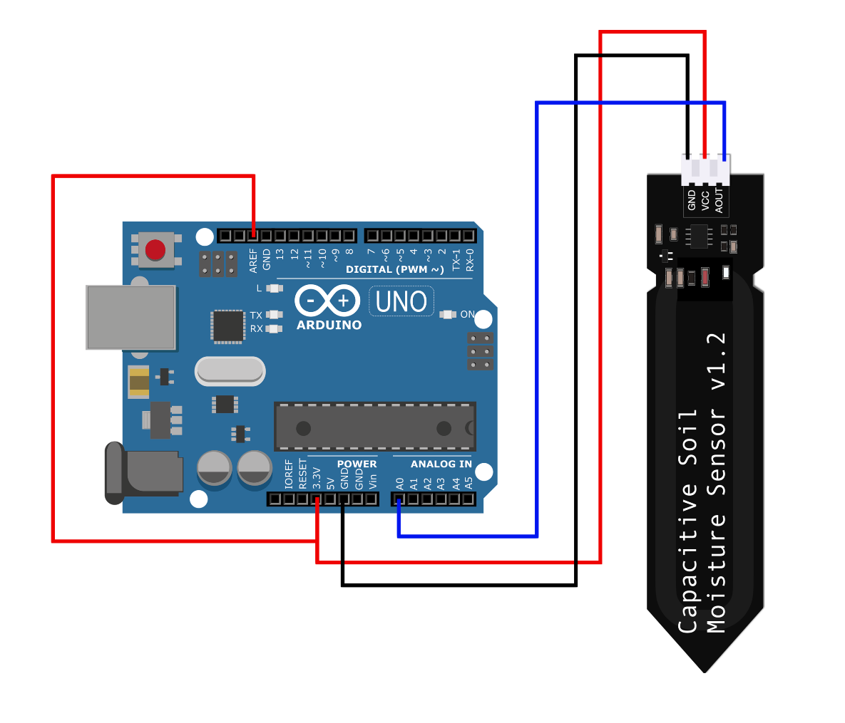

Fig 3.1 System Architecture

* 1. **REQUIREMENT SPECIFICATION**

**3.2.1 HARDWARE SPECIFICATION**

Arduino Uno board

Connecting wires

Capacitive soil Moisture sensor version 2

Indicators: led light (red, green, yellow)

Monitor (display output) through Arduino app

**3.2.2 SOFTWARE SPECIFICATION**

Arduino IDE

Windows 11

* 1. **COMPONENTS USED**

**Capacitive Sensor:**

Capacitive sensors are integral to soil moisture checking, offering high accuracy and reliability. These sensors utilize capacitance principles, measuring changes in soil moisture by detecting alterations in soil dielectric properties. With electrodes embedded within the soil, capacitive sensors provide continuous monitoring across various depths. They excel in sensitivity, promptly identifying water stress in crops for timely intervention. Known for durability and low power consumption, they're ideal for long-term deployment. Advanced models transmit data wirelessly to centralized platforms, facilitating real-time monitoring and remote access. Capacitive sensors are indispensable tools for optimizing water usage, enhancing crop productivity, and fostering sustainable agricultural practices.

**Led Lights:**

LED lights are commonly used in IoT (Internet of Things) projects for several reasons. Firstly, LED lights are highly energy-efficient, consuming significantly less power compared to traditional incandescent bulbs. This makes them ideal for IoT devices, which often operate on battery power or need to minimize energy consumption to prolong battery life. Additionally, LEDs offer long lifespans, reducing the need for frequent replacement and maintenance, which is particularly advantageous in remote or hard-to-reach locations where IoT devices may be deployed. Moreover, LEDs are available in a wide range of colors and can be easily controlled using microcontrollers or IoT platforms, allowing for dynamic lighting effects and customizable functionality in IoT applications. Furthermore, LEDs produce minimal heat compared to other lighting technologies, making them safer to use in enclosed or sensitive environments. Overall, the energy efficiency, longevity, versatility, and controllability of LED lights make them a preferred choice for integration into IoT projects, enabling innovative and efficient lighting solutions across various applications.

**Jumper Cables:**

Jumper cables are used to create electrical connections between components on a breadboard or between components and the Capacitive Sensor.

They typically consist of insulated wires with male or female connectors on each end, making them versatile for connecting different components in a circuit.

**Breadboard:**

A breadboard is a prototyping tool used to create temporary circuits without the need for soldering. It consists of a grid of interconnected metal strips embedded in a plastic base.

Components can be inserted into the holes on the breadboard, and jumper cables can be used to make connections between them, allowing for quick and easy experimentation and testing of circuits.

# WORKING PRINCIPLE

In a simple RC circuit like this, when a positive voltage is applied to the Input, the capacitor (C) begins to charge through the resistor (R). As it does, the voltage across the capacitor changes. Over time, the capacitor voltage rises to equal input voltage. Here, you can see a graph plotting voltage against time for the charging capacitor. The time it takes for the capacitor to fully charge depends on the values of the resistor and the capacitor. If you keep the R constant and try two different capacitance values for C, you will observe that a capacitor with a larger capacitance requires more time to charge, whereas a capacitor with a smaller capacitance requires less time to charge.

Now coming back to our sensor, the capacitor C on the sensor board is not a literal component, but simply two copper traces that act like a capacitor. This effect, known as Parasitic Capacitance, happens often in circuits and is usually negligible. However, by deliberately making the two copper traces larger, we can use this effect to our advantage. The capacitance of this parasitic capacitor is determined by the shape of the traces and the environment surrounding it (technically known as the dielectric constant). As the sensor is inserted into the soil, the environment around the capacitor changes depending on whether the soil becomes wetter or drier. This alters its capacitance, and consequently, affects its charging time.

When the soil is dry, the capacitor has a smaller capacitance and therefore charges up quickly. Conversely, when the soil is wet, the capacitor has a larger capacitance and therefore charges up more slowly.

The sensor uses a 555 configured as an astable oscillator. The square waves generated by the 555 are fed into the RC integrator, of which the capacitor is formed by the soil probe. The signal from the integrator is more of a triangular wave, which is fed into the rectifier and a smoothing capacitor to produce a DC output.

# CHAPTER4 RESULT AND DISCUSSION

* 1. **ALGORITHMDescription**

In the initial phase of our soil moisture monitoring algorithm, we meticulously configure and calibrate the hardware components, ensuring optimal performance. This includes setting up sensors, microcontrollers, and actuators, and establishing communication protocols between them. Once the system is operational, we continuously gather sensor data, employing signal processing techniques to refine and enhance the accuracy of our measurements. Subsequently, we compare these readings against predefined thresholds, determining whether the soil moisture levels are within the desired range or if corrective action is needed. Upon detecting moisture levels below the threshold, the system activates irrigation mechanisms, ensuring timely and efficient watering of the soil. Conversely, if moisture levels are satisfactory, the system logs the data for further analysis and trend identification. Throughout this process, a feedback loop is maintained, allowing for dynamic adjustments to watering schedules based on environmental conditions and plant needs. To ensure the system's robustness and reliability, comprehensive error handling mechanisms are implemented, capable of diagnosing and addressing any malfunctions or anomalies in real-time. Furthermore, regular maintenance procedures are scheduled to uphold the system's longevity and accuracy, including sensor recalibration and software updates to adapt to evolving conditions.

|  |  |
| --- | --- |
| **Component** | **Function** |
| Arduino Uno board | It serves as the heart of many DIY electronics projects, offering a simple yet powerful platform for prototyping and development. |
| Capacitive soil Moisture sensor version 2 | It offers improved sensitivity and accuracy compared to its predecessor, enabling precise measurement of soil moisture levels. With its non-corrosive design and low power consumption, it's an excellent choice for long-term monitoring applications. |
| Indicators(LED) | The Capacitive Soil Moisture Sensor Version 2 employs LED indicators to display power status and real-time soil moisture levels, offering convenient visual feedback for users. |
| Power Supply | Provides electrical power to the board and connected devices. |
| Breadboard | Facilitates prototyping and assembling of components. |
| Jumper Cables | Used for connecting components on the breadboard, aiding in circuit assembly. |

Table 4.1Component Table

# 4.2 IMPLEMENTATION:

Implementing the Capacitive Soil Moisture Sensor Version 2 is a straightforward process that requires careful hardware setup, software configuration, calibration, and integration with a microcontroller.

To begin, the hardware setup involves connecting the sensor to an Arduino Uno board using jumper wires. The sensor typically has three pins: VCC (power), GND (ground), and SIG (signal). VCC is connected to the 5V pin on the Arduino, GND to the ground pin, and SIG to an analog input pin, such as A0. Optionally, LEDs can be connected to the Arduino for visual feedback on power status and moisture levels.

Next, the software configuration involves installing the Arduino IDE and any necessary sensor libraries. This allows for the uploading of example code provided by the sensor manufacturer or custom Arduino sketches. These sketches are designed to read sensor data and control LEDs based on moisture levels.

Calibration is a crucial step to ensure accurate readings from the sensor. This involves initializing the sensor and conducting a calibration process to establish baseline moisture values. These values are then mapped to corresponding moisture levels, enabling accurate interpretation of sensor readings.

# CHAPTER 5

# OUTPUTS

# OUTPUT:

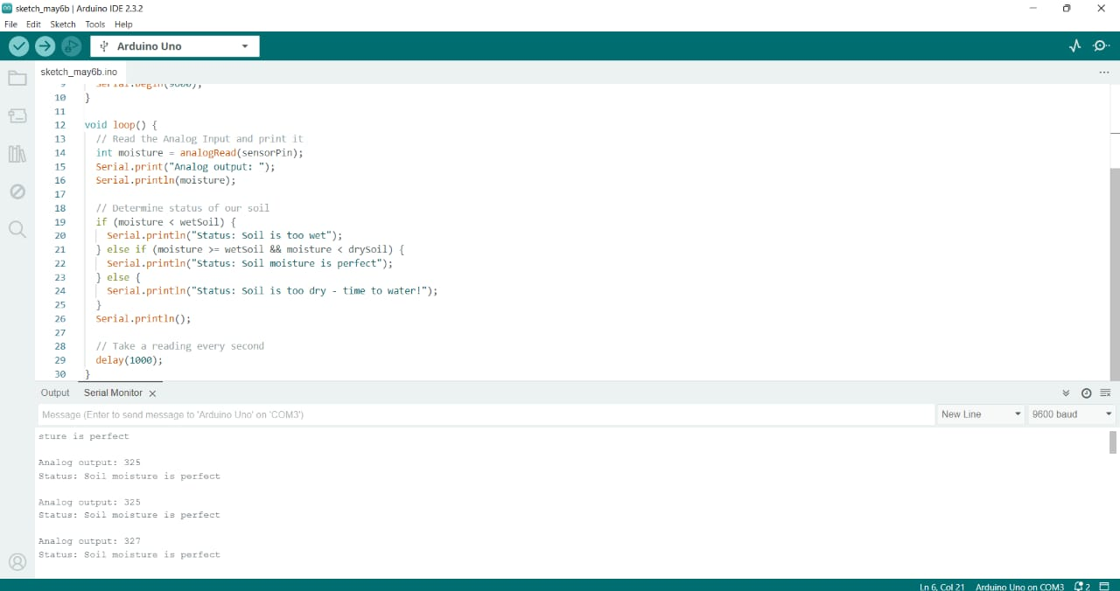

Fig 5.1: Output screen

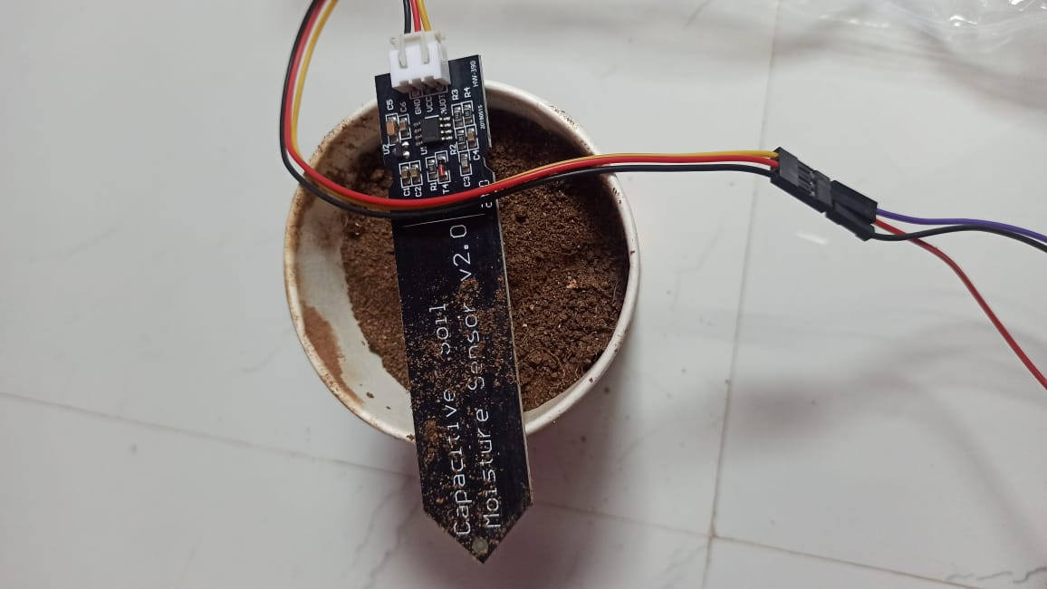

Fig 5.2: Capacitive soil Moisture sensor version 2

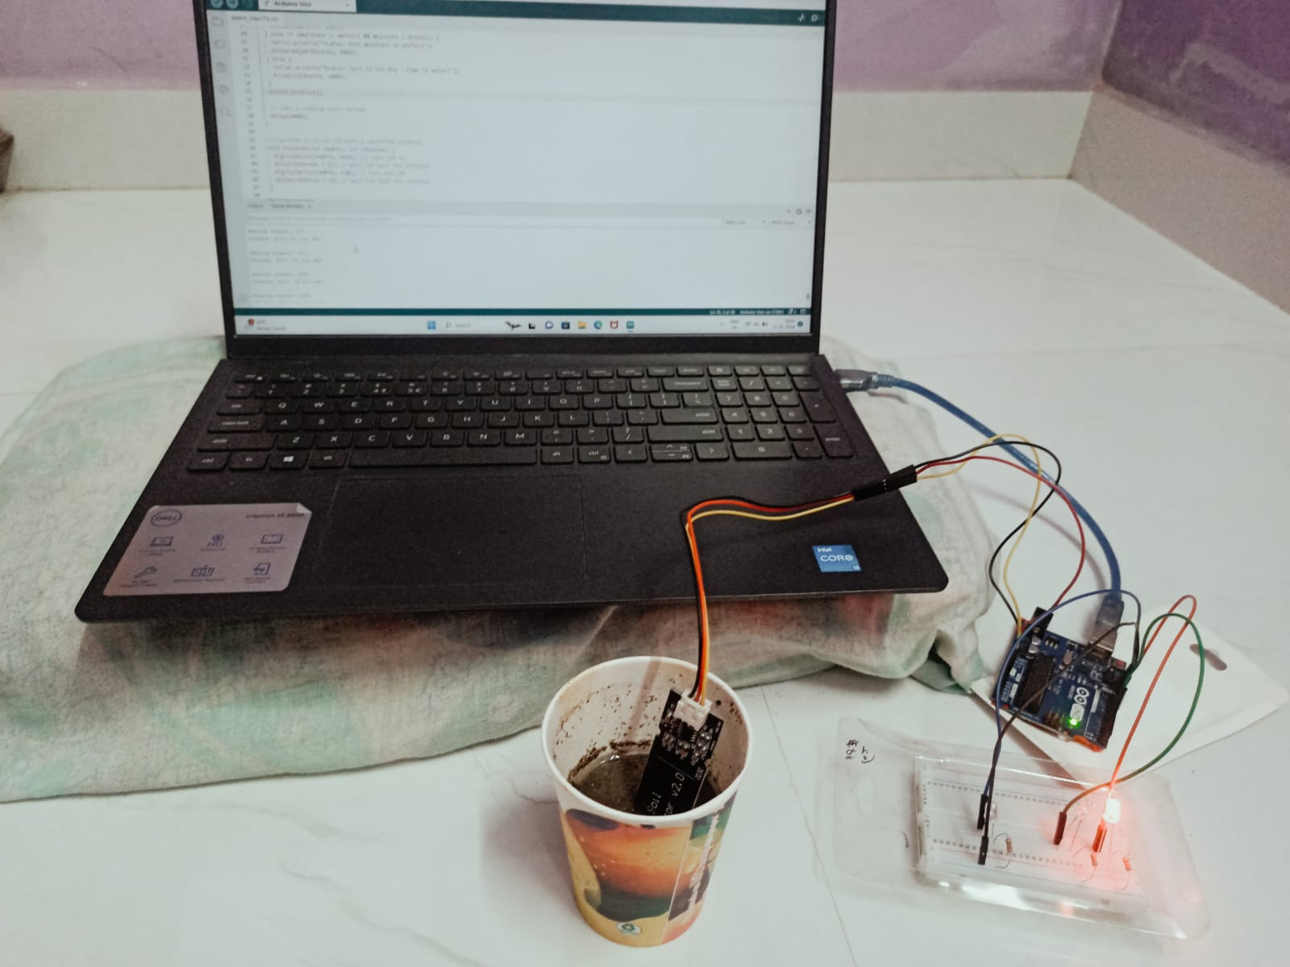

Fig 5.3 : Project Setup

# 

# Fig 5.4 : Too wet - indicates red color

# 

# Fig 5.5: Perfect moisture soil for plants indicates green color

# 

# 

# Fig 5.6 : Too dry - Time to water soil ( indicates blue colour)

# SECURITY MODEL:

The security model for the Capacitive Soil Moisture Sensor Version 2 encompasses several key measures to safeguard both data integrity and user privacy. Utilizing data encryption during transmission, unauthorized access or tampering with sensor readings is prevented. Authentication mechanisms, like secure protocols such as OAuth or API keys, ensure only authorized users or devices can access data and control functionalities. Physical security features, such as tamper-resistant enclosures, protect the sensor itself from manipulation. Regular security audits and updates are conducted to identify and mitigate potential vulnerabilities in the sensor's software or firmware. These comprehensive measures collectively reinforce the reliability and confidentiality of sensor data, instilling trust in its application across agricultural, gardening, and environmental monitoring domains. In addition to data encryption, authentication mechanisms, physical security features, and regular security audits, the security model for the Capacitive Soil Moisture Sensor Version 2 includes several supplementary measures. These encompass granular data access controls to restrict data access based on user roles, ensuring sensitive information is only accessible to authorized entities. Moreover, the implementation of data redundancy and backup mechanisms safeguards against data loss due to hardware failures or malicious activities, guaranteeing data availability and integrity. Secure firmware update procedures are also integrated to authenticate and authorize updates, mitigating the risk of unauthorized modifications. Furthermore, comprehensive logging and monitoring capabilities enable the detection of security breaches or anomalous behavior in real-time. Additionally, adherence to relevant security certifications or industry-standard frameworks provides assurance regarding the sensor's reliability and compliance with established security protocols. By incorporating these additional security measures, the Capacitive Soil Moisture Sensor Version 2 fortifies its ability .

# CHAPTER 6

**CONCLUSION AND FUTURE WORK**

# CONCLUSION

In conclusion, the Capacitive Soil Moisture Sensor Version 2 represents a significant advancement in soil moisture monitoring technology, offering enhanced accuracy, reliability, and versatility for agricultural, gardening, and environmental monitoring applications. Through its innovative design and robust features, this sensor provides users with invaluable insights into soil moisture levels, enabling informed decision-making and optimized resource utilization.

The implementation of the Capacitive Soil Moisture Sensor Version 2 involves careful consideration of hardware setup, software configuration, calibration, and integration with a microcontroller. By following established guidelines and best practices, users can effectively deploy the sensor in various environments and achieve optimal performance.

Furthermore, the security model implemented in the Capacitive Soil Moisture Sensor Version 2 prioritizes data integrity and user privacy. Through a combination of encryption, authentication mechanisms, physical security features, and regular audits, the sensor ensures that sensitive information is protected from unauthorized access or tampering. Additional measures such as data access controls, redundancy, secure firmware updates, and logging capabilities further enhance the sensor's security posture, instilling confidence in its reliability and compliance with industry standards.

Looking ahead, the Capacitive Soil Moisture Sensor Version 2 holds promise for continued innovation and advancement in soil monitoring technology. As technology evolves and user needs evolve, ongoing research and development efforts will further refine the sensor's capabilities, expanding its applications and enhancing its usability.

Moreover, the widespread adoption of the Capacitive Soil Moisture Sensor Version 2 has the potential to revolutionize agriculture, enabling more efficient water management practices, increased crop yields, and reduced environmental impact. By providing farmers, gardeners, and researchers with real-time access to accurate soil moisture data, the sensor empowers them to make data-driven decisions that optimize resource allocation and promote sustainable land management practices.

In summary, the Capacitive Soil Moisture Sensor Version 2 represents a cornerstone in the field of soil moisture monitoring, combining advanced technology with robust security measures to deliver reliable, actionable insights for a variety of applications. As it continues to evolve and adapt to changing user needs and technological advancements, the sensor holds the potential to drive significant improvements in agriculture, environmental sustainability, and resource management on a global scale.

# FUTURE WORK

Looking ahead, there are several promising directions for future work and advancement of the Capacitive Soil Moisture Sensor Version 2. Firstly, refining the sensor's calibration algorithms and signal processing techniques could significantly enhance accuracy and reliability in soil moisture measurements. Integration with IoT platforms holds potential for enabling remote monitoring and data analytics, empowering users with real-time access to soil moisture data from anywhere. Exploring the deployment of multi-sensor networks and advanced data analytics techniques can provide comprehensive insights into soil moisture dynamics across diverse landscapes, facilitating more informed decision-making in agricultural management. Moreover, the development of energy-efficient designs and cross-domain applications can expand the sensor's usability and sustainability, catering to a broader range of industries and use cases. Collaboration with stakeholders such as researchers, farmers, and environmental organizations is essential for co-designing tailored solutions and ensuring practical relevance.

By pursuing these avenues for future work, the Capacitive Soil Moisture Sensor Version 2 can continue to evolve as a versatile and indispensable tool for soil moisture monitoring, contributing to advancements in agriculture, environmental sustainability, and resource management.

Additionally, exploring advancements in sensor technology, such as novel materials or sensor configurations, could unlock new possibilities for improving sensitivity, durability, and cost-effectiveness. Investigating the integration of complementary sensors, such as temperature or humidity sensors, could provide deeper insights into soil-plant-atmosphere interactions, enhancing the sensor's overall utility in precision agriculture and environmental monitoring applications. Furthermore, the development of predictive modeling techniques based on historical sensor data and environmental variables could enable proactive decision-making and risk management strategies. Embracing interdisciplinary research and fostering collaborations across fields like agronomy, engineering, and data science can accelerate innovation and address complex challenges in soil moisture monitoring. Finally, prioritizing user-centric design principles and accessibility considerations can ensure that sensor technologies are inclusive and equitable, benefiting a diverse range of users and stakeholders.

# REFERENCES

1. Vijay Madisetti, ArshdeepBahga, “Internet of Things: A Hands-On Approach”, 2014, www.internet-of-things-
2. book.com
3. Perry Lea, “Internet of Things for Architects” ,Packt Publishers ,2018.
4. Martin Bauer Mathieu Boussard Nicola Bui Jourik De Loof et.al,” IoT Reference Architecture”, DOI: 10.1007/978-3-
5. 642-40403-0_8 Springer.
6. Jan Holler, VlasiosTsiatis, Catherine Mulligan, Stefan Avesand, Stamatis Karnouskos, David Boyle, “From Machine-
7. to-Machine to the Internet of Things: Introduction to a New Age of Intelligence”, 1st Edition, Academic Press, 2014.
8. Reference Book(s)/Web link(s):
9. Dr.OvidiuVermesan, Dr. Peter Friess, “Internet of Things: Converging Technologies for Smart Environments and
10. Integrated Ecosystems”, River Publishers,2013.
11. Peter Waher, “Learning Internet of Things”, Packt Publishing, Birminghan – Mumbai,2015
12. Bernd Scholz-Reiter, Florian Michahelles, “Architecting the Internet of Things”, ISBN 978-3-642-19156, e-ISBN 978-
13. 3-642-19157-2, Springer,2011.

# APPENDIX

Arduino Uno Final Program:

#define wetSoil 277 // Define max value we consider soil 'wet'

#define drySoil 380 // Define min value we consider soil 'dry'

// Define analog input

#define sensorPin A0

#define wetLED 10 // Define wet LED pin

#define perfectLED 6 // Define perfect moisture LED pin

#define dryLED 12 // Define dry LED pin

void setup() {

Serial.begin(9600);

pinMode(wetLED, OUTPUT); // Initialize wet LED pin as an output

pinMode(perfectLED, OUTPUT); // Initialize perfect moisture LED pin as an output

pinMode(dryLED, OUTPUT); // Initialize dry LED pin as an output

}

void loop() {

// Read the Analog Input and print it

int moisture = analogRead(sensorPin);

Serial.print("Analog output: ");

Serial.println(moisture);

// Determine status of our soil

if (moisture < wetSoil) {

Serial.println("Status: Soil is too wet");

blinkLED(wetLED, 2000);

} else if (moisture >= wetSoil && moisture < drySoil) {

Serial.println("Status: Soil moisture is perfect");

blinkLED(perfectLED, 2000);

} else {

Serial.println("Status: Soil is too dry - time to water!");

blinkLED(dryLED, 2000);

}

Serial.println();

// Take a reading every second

delay(1000);

}

// Function to blink LED with a specified interval

void blinkLED(int ledPin, int interval) {

digitalWrite(ledPin, HIGH); // Turn LED on

delay(interval / 2); // Wait for half the interval

digitalWrite(ledPin, LOW); // Turn LED off

delay(interval / 2); // Wait for half the interval

} Serial.println();

// Take a reading every second

delay(1000);

}